GLOBAL CLAIMS SYSTEM

Test Automation Documentation

**Contents**

1. Test Automation Framework
2. Hybrid Test Automation
3. Pre-requisites
4. Automation Project Set Up
5. Framework Folder Structure
6. Framework Architecture
7. Pictorial Representation of Framework Flow
8. Framework Flow Explanation
9. Test Data Explanation
10. How to Execute the Test Scripts.
11. Result Analysis

**Test Automation Framework**

 A testing framework is a set of guidelines or rules used for creating and designing test cases. A framework is comprised of a combination of practices and tools that are designed to help QA professionals test more efficiently.

**Hybrid Automation Framework**

Hybrid Test automation framework is the combination of two or more frameworks. Its uses strengths and benefits of other frameworks for the particular test environment. Test automation frameworks boost productivity with standardization.

**Pre-requisites**

* JDK 1.8
* TestNG
* Git Bash
* Java Project
* Eclipse IDE

**Code Location**

https://github.com/TYSS-HCL/HCL_GCS_Final.git

**Automation Setup**

1. Open eclipse.
2. Create a workspace where you want to store the project.
3. Click on go to workspace symbol on the eclipse welcome screen.
4. Click on Window-> Show View-> Project Explorer.
5. Right Click in package Explorer, import->import->Projects from git->Clone URI->Enter git URI Provide username and password->select the main branch->next-> finish.

**Framework Folder Structure**

The following figure describes the folder structure with the description.

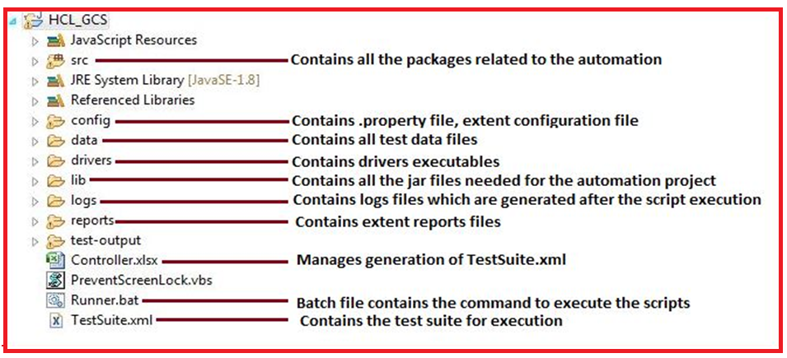

Below pictures represents the package structure of the automation framework.

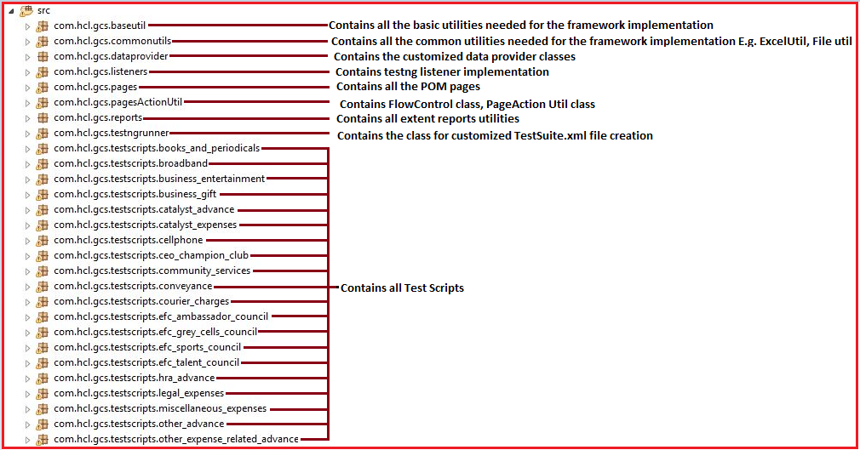

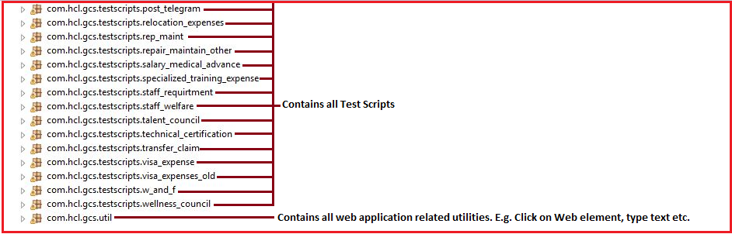

Below picture shows the different java classes under the packages which have the implementation of all the generic as well as the specific methods to be used to test the web application.

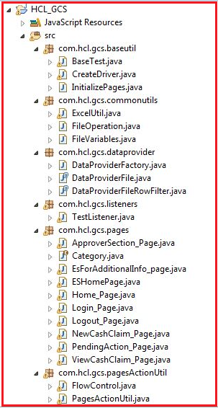

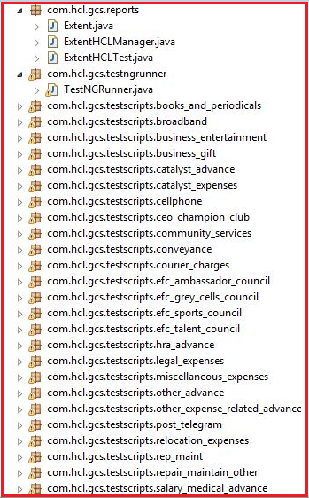

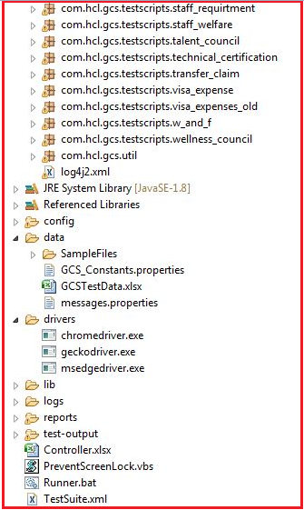

**Framework Architecture**

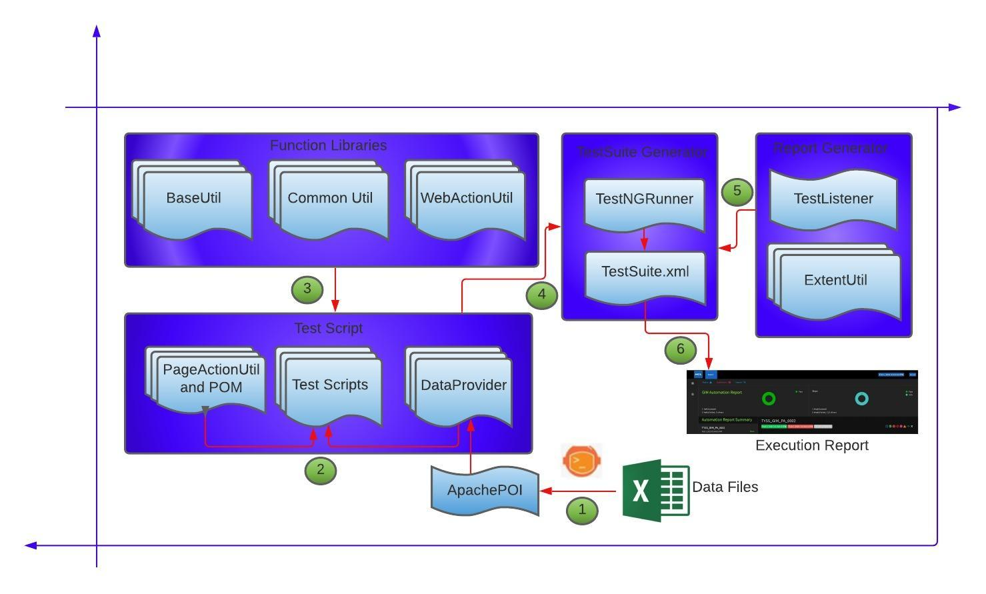

**Base Util**: Contains Base Test, InitializePage.java. Base Test contains all the pre- and post-condition implementation, such as creating the folder structure for the reports, Launching the browser and entering the URL, close the browser. InitializePage.java has the object creation of all the POM pages.

**CommonUtil**: Contains Excel Util, File Variables, and File Operations classes. Excel util has the implementations of all the excel functions using apache poi, fillo. File Operations and Variables contain the implementations of the File handling needed in the application.

**WebActionUtil**: Contains all the implementations of the actions to be performed on the browser.

**POM**: Contains all the pages of the application. All the pages are created using Page Object Model Approach. These pages contain all the reusable methods.

**PageActionUtil:** Contains methods for different flows. PageActionUtil methods are built by integrating methods of the POM pages. According to the Flow PageActionUtil methods will be invoked by FlowControl method.

**Test Scripts**: The Test cases are converted into the scripts using the reusable methods from the POM pages, data providers.

**Data Providers**: The customized data providers are used to fetch the data from the excel file.

**Test Listeners**: Contains the implementations for methods from the ITestListener with extent reports implementations.

**ExtentUtil**: Contains the implementation of the extent reporting.

**TestNGRunner**: This class is used to generate TestNG.xml (anyname.xml) dynamically which is used to drive all the TestNG classes. This reads Controller.xlsx file which contains package name in a column and class Name in another column named Test case Id. Based on the status 'Yes'/'No’, the TestNG.xml will contain only those classes where status is 'Yes'.

**Config**: This folder contains extent-config xml file, config properties.

**Drivers**: This folder contains all the driver executable files for launching the browsers.

**Lib**: This folder contains all the jar files required for this project.

**Data**: This folder contains all the test data files required for this project.

**Pictorial Representation of the Framework**

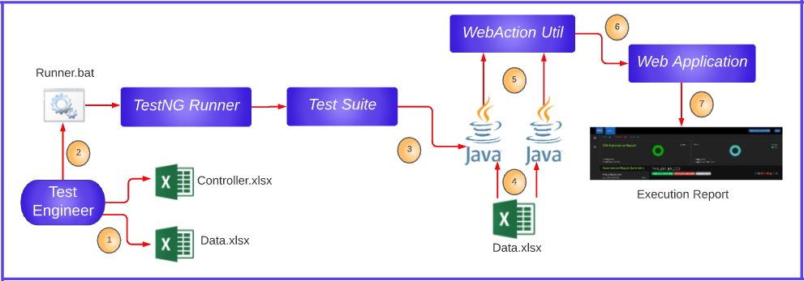

**Framework Flow Execution**

* **Step 1**: The Test Engineer modifies the controller.xlsx and data.xlsx file.
* **Step 2**: The Test engineer triggers the Runner.bat file. The Runner.bat triggers the execution of the whole framework. The TestNG runner creates the TestSuite.xml depending on the Controller.xlsx. The selection of the test scripts for the execution and mode of the test execution can be controlled by the values in the controller.xlsx file
* **Step 3**: The Testsuite.xml executes the test scripts.
* **Step 4**: The test script fetches the data from the data.xlsx file with the use of a data provider.
* **Step 5**: Test scripts trigger the base test where actions like creating the folder structure for extent reports, launching the applications, creating the node for the test in the extent reports according to the test class. Also triggers the Web Action util.
* **Step 6**: The selenium script performs action on the web application under test using the common utilities and action utilities.
* **Step 7**: The results of the execution are recorded in the extent report.

**Test Data Preparation**

**Data Preparation**:

**a**. **LoginCredentials sheet:**

1. Enter the login credentials of all the roles required for different claim.

2. Data should be added according to the column names.

3. According to the claim type, the LoginCredentials sheet should be updated with login credentials of the approvers mapped to claim.

Note: 1. do not change the sheet name, and the column names.

2. All the data that is updated should be unique.

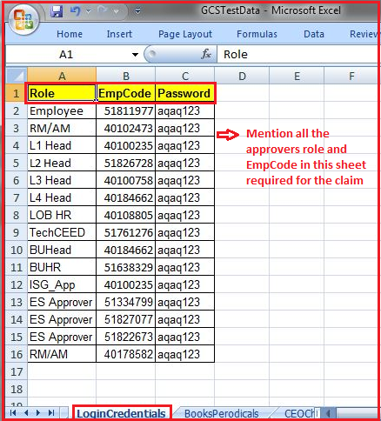

**b**. **Claim Type Data Preparation (E.g. Books and Periodicals)**

1. The data is updated in different sheets according to the claim type.
2. Data for the particular claim should be unique according to requirement.

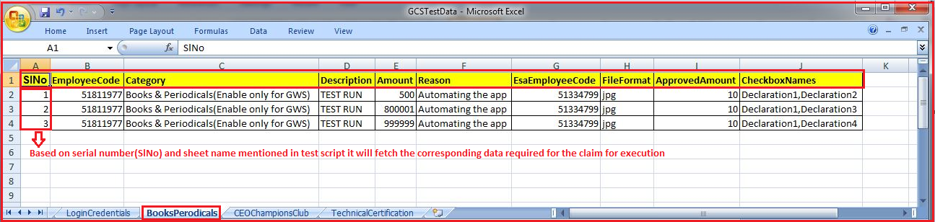

* **Data fetching explanation:**

Customized data provider code is written in DataProviderFactory class.

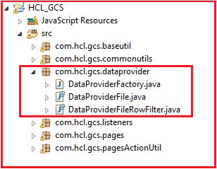

Below picture explains the data fetching in Test script.

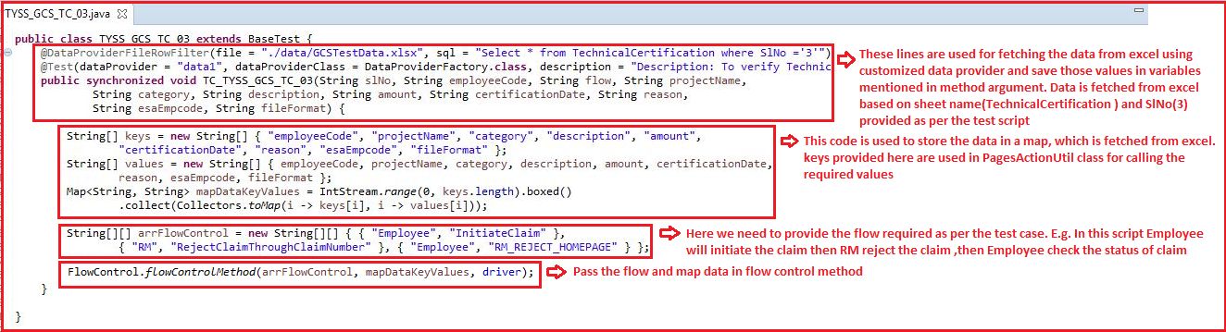

Below picture explains the Flow Control class.

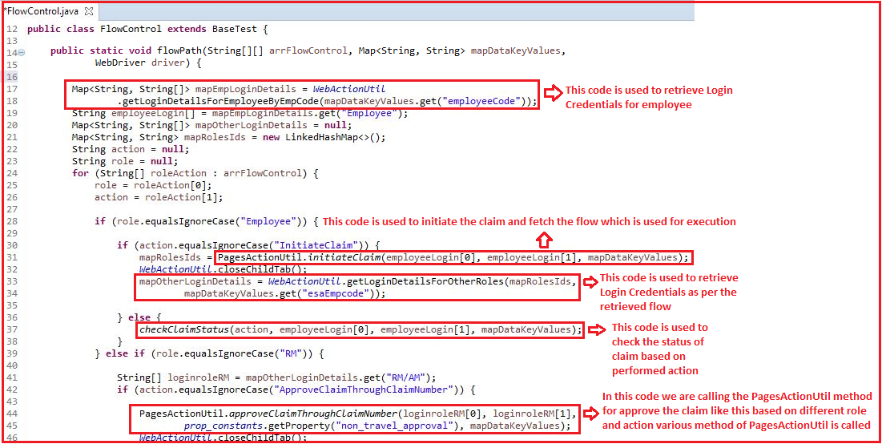

**When we perform actions like Initiate claim, Approve claim, Referback claim, Reject claim then we need to pass the Role in below mentioned format.**

|  |  |
| --- | --- |
| **Role** | **Role Format to be mentioned in the flow** |
| Employee | Employee |
| RM | RM |
| ES approver | ES Approver |
| L1 head | L1 Head |
| L2 head | L2 Head |
| L3 head | L3 Head |
| L4 head | L4 Head |
| BU head | BU Head |
| BUHR | BUHR |
| LobHR | LOB HR |
| Techceed | TechCEED |
| Exceptional approver | EXP_APP |
| ISG approver | ISG_APP |

**When we perform actions like Initiate claim, Approve claim, referback claim, Reject claim then we need to pass Action in below mentioned format.**

|  |  |
| --- | --- |
| **Action** | **Action format to be mentioned in the flow** |
| For Initiate the claim | Initiate Claim |
| Approve the claim after click on claim number | ApproveClaimThroughClaimNumber |
| Approve the claim by click on Approve Icon | ApproveClaimThroughIcon |
| Refer back the claim after click on claim number | ReferBackClaimThroughClaimNumber |
| Refer back the claim by click on referback icon | ReferBackClaimThroughIcon |
| Reject the claim after click on claim number | RejectClaimThroughClaimNumber |
| Reject the claim by click on reject icon | RejectClaimThroughIcon |
| Approve Claim in ES Page | ApproveClaim |
| ReferBack claim in ES Page | ReferBackClaim |
| RejectClaim in ES page | RejectClaim |

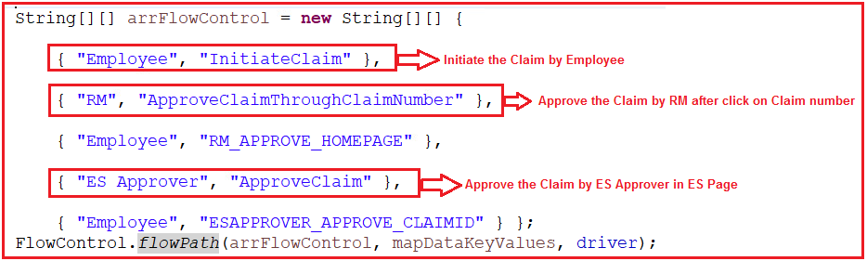

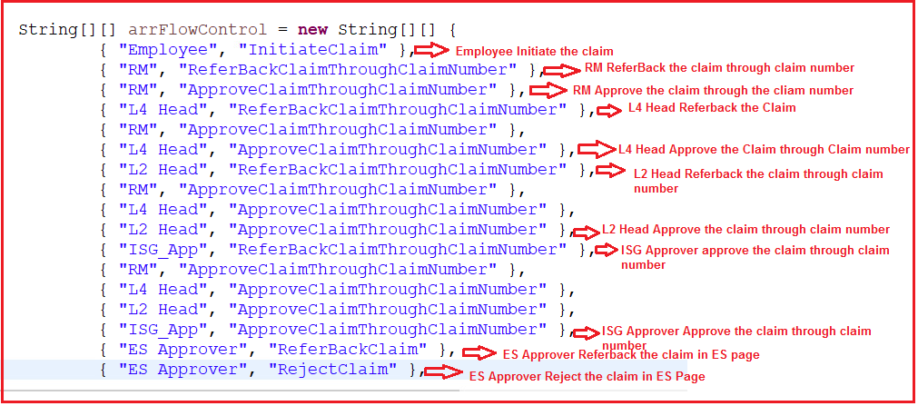

**When we need to check the status of the claim like Approve claim status, Referback claim status, Reject claim status then we needs to write in below mentioned format.**

|  |  |
| --- | --- |
| **Status of the claim** | **Status format to be mentioned in the flow** |
| Check the status of the Claim after approve by any Role in Home Page Ex. RM | RM_APPROVE_HOMEPAGE |
| Check the status of the Claim after approve by any Role after Click on Claim Number Ex. RM | RM_APPROVE_CLAIMID |
| Check the status of the Claim after referback by any Role in Home Page Ex. RM | RM_REFERBACK_HOMEPAGE |
| Check the status of the Claim after referback by any Role after Click on Claim Number and then Reinitiate the Claim Ex. RM | RM_REFERBACK_CLAIMID |
| Check the status of the Claim after reject by any Role in Home Page Ex. RM | RM_REJECT_HOMEPAGE |
| Check the status of the Claim after reject by any Role after Click on Claim Number Ex. RM | RM_REJECT_CLAIMID |

**Note:**

Above mentioned RM Role can be replaced by different Roles. That role need to pass in below mentioned format.

**When we need to check the status of the claim like Approve claim status, referback claim status, Reject claim status then we needs to pass the Role in below mentioned format.**

|  |  |
| --- | --- |
| **Role** | **Role Format to be mentioned in the flow** |
| RM | RM |
| ES approver | ESAPPROVE |
| L1 head | L1HEAD |
| L2 head | L2HEAD |
| L3 head | L3HEAD |
| L4 head | L4HEAD |
| BU head | BUHEAD |
| BUHR | BUHR |
| LobHR | LOBHR |
| Techceed | TECHCEED |
| Exceptional approver | EXPAPP |
| ISG approver | ISGAPPROVER |

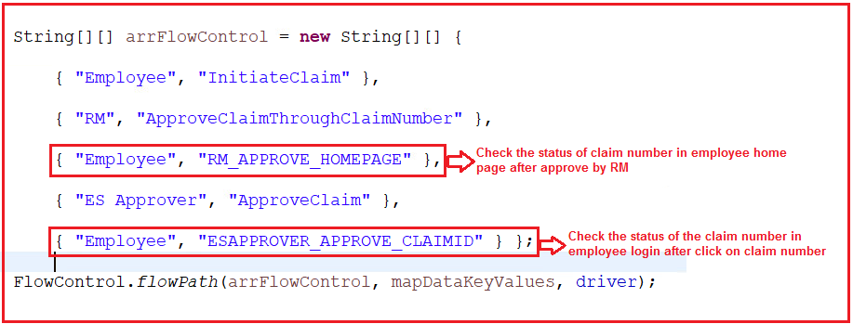

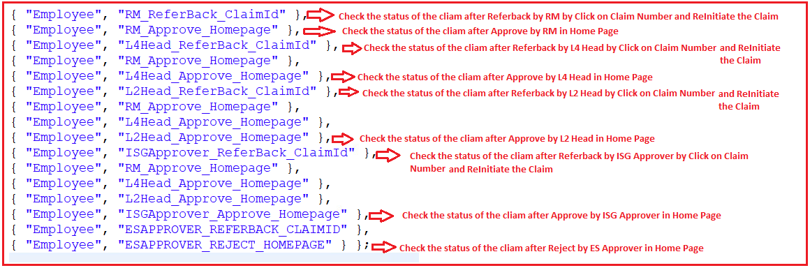



**Method 1: Import the code in Eclipse by using Projects from Git:**

1. Open the given URL <https://github.com/> and Click on sign in.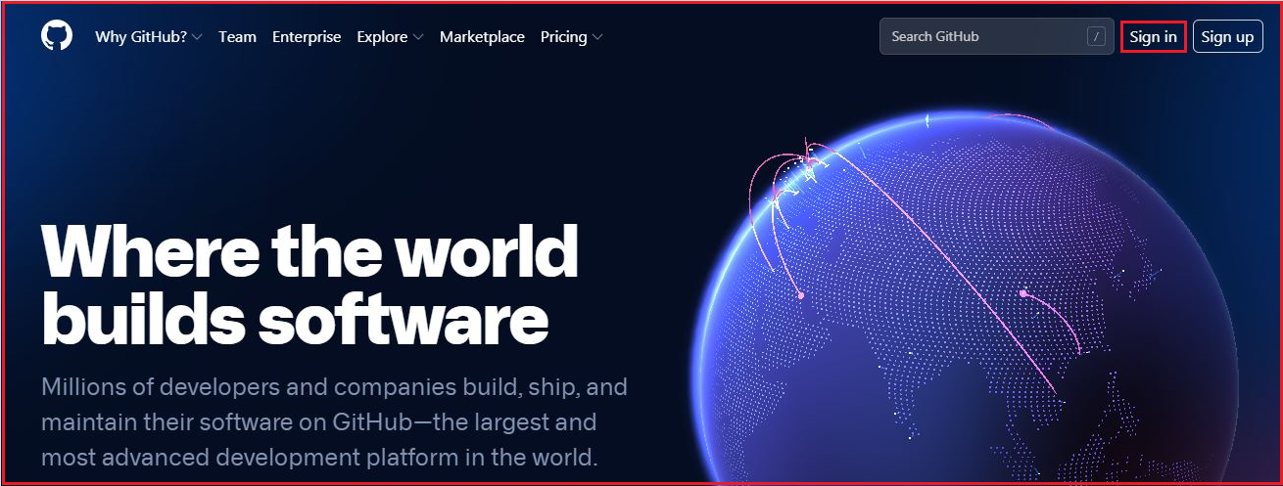

2. Enter your credentials and click on sign in.

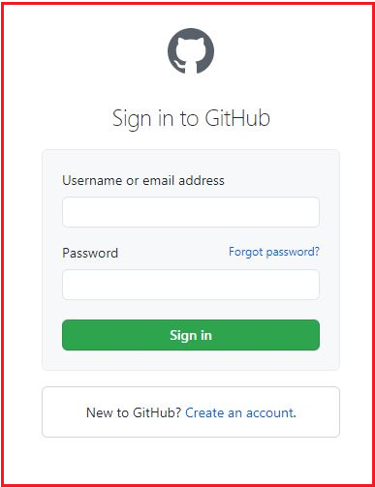

* Create the Token in git hub by following below steps:

3. Click on the My Profile dropdown & select settings.

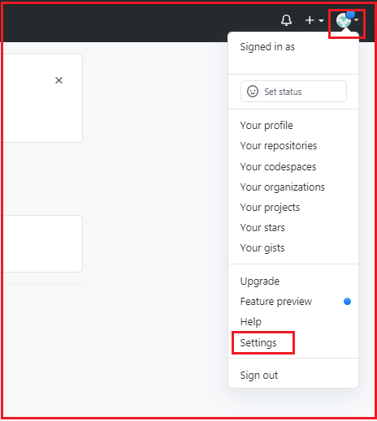

4. Click on Developer settings.

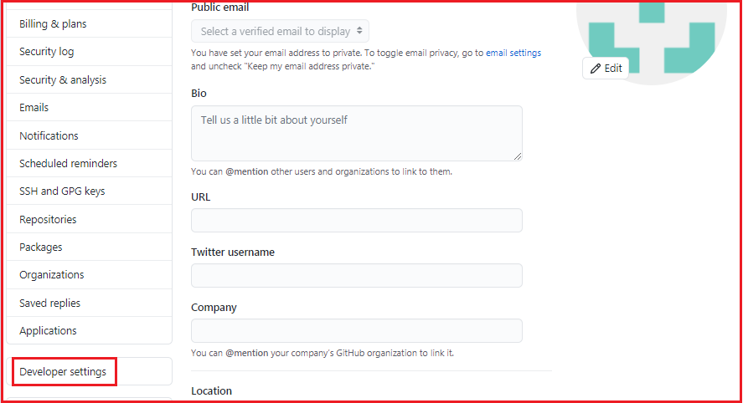

5. In developer settings, select Personal access token &then click on Generate new token.

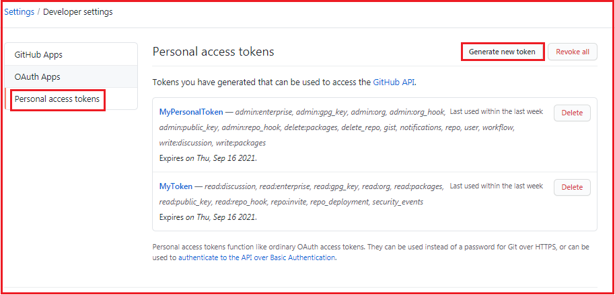

6. Enter the Github account password.

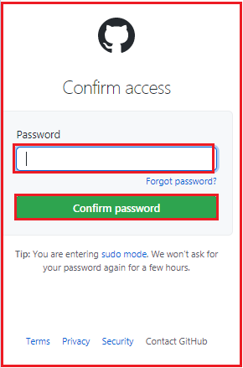

7.Provide any name in **Note** text field & select all the checkboxes.

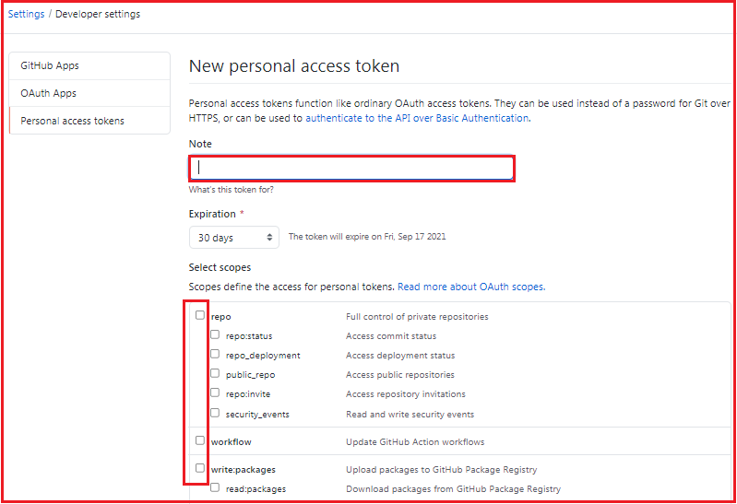

8. Click on Generate Token.

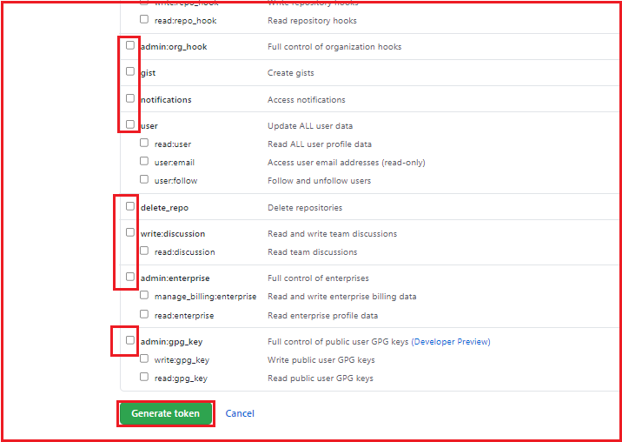

9. Copy & save the generated token for future reference.

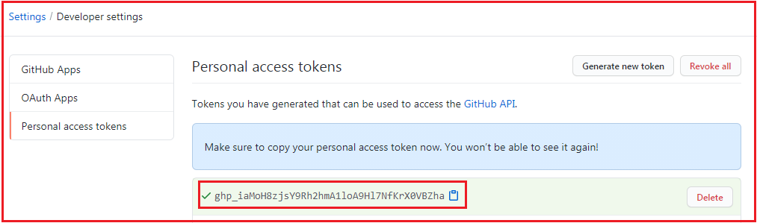

10. Project has been shared to the mentioned Git account by the Lead/Manager. Accept the invitation in email and you can see the project in your git account. Click on project.

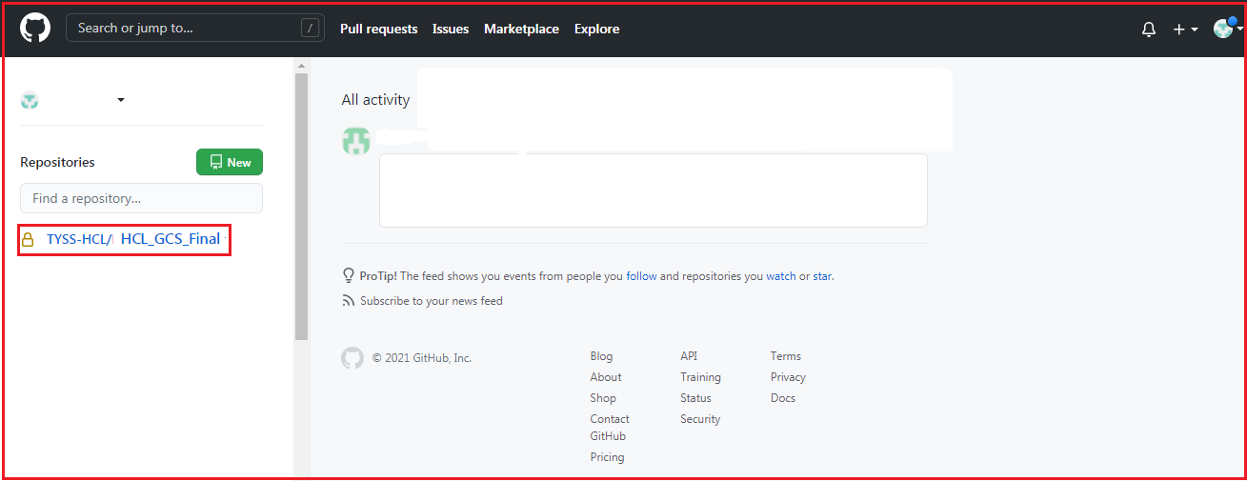

11. Click on code and copy the URL.

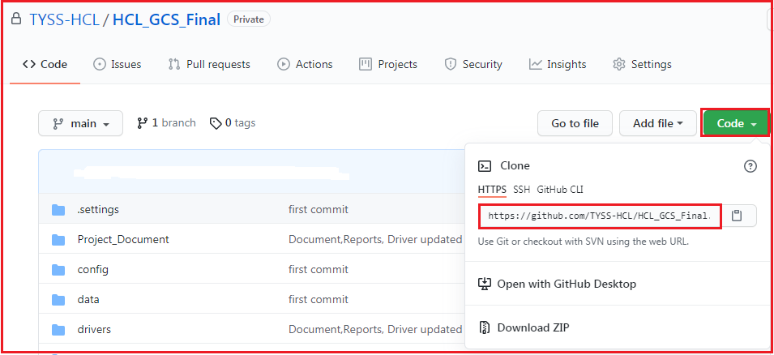

12. Open the eclipse and create a workspace (Create a folder in your system) and click on launch.

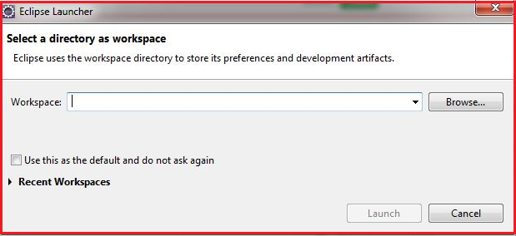

13. Click on file then click on import.

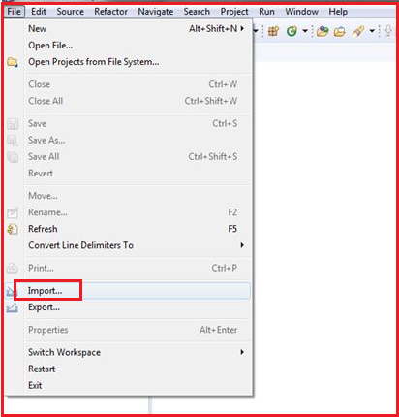

14. In Git option click on Projects from Git then click on next.

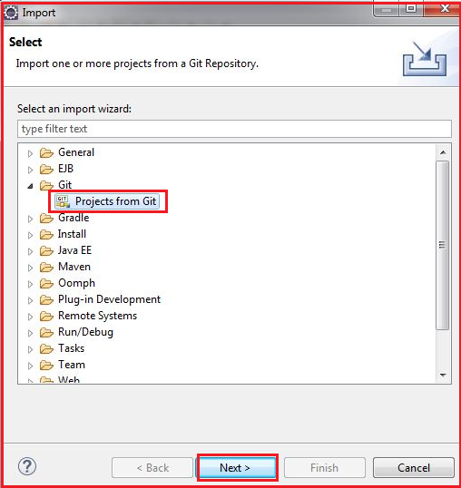

15. Click on Clone URI then click next.

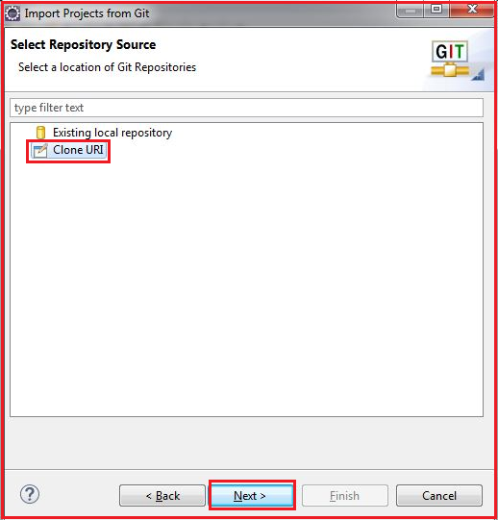

16. Paste the URL in URI section copied in step 11, then click on next.

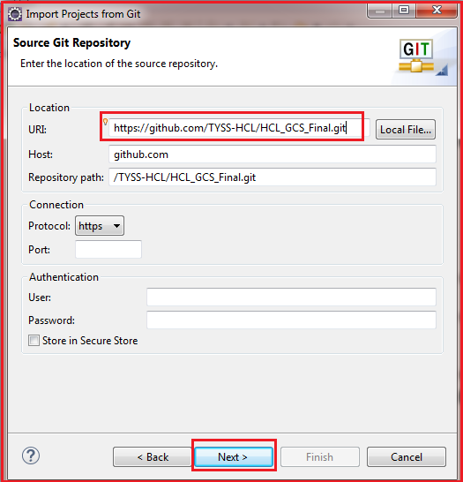

17.Enter the Github Username & pass the token copied in 9th step into the Password text field.

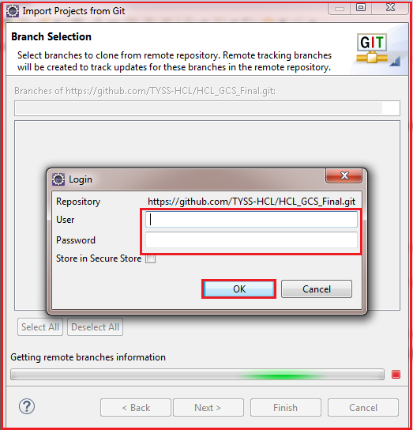

18. Select the main branch then click on next.

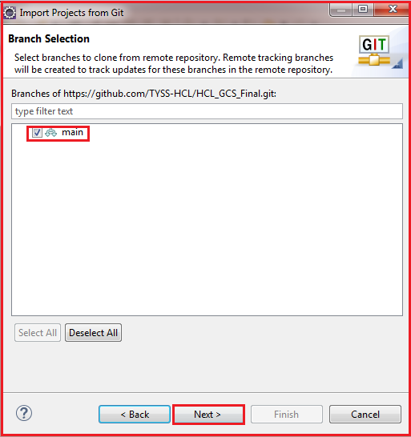

19. Select the directory for git then click on next.

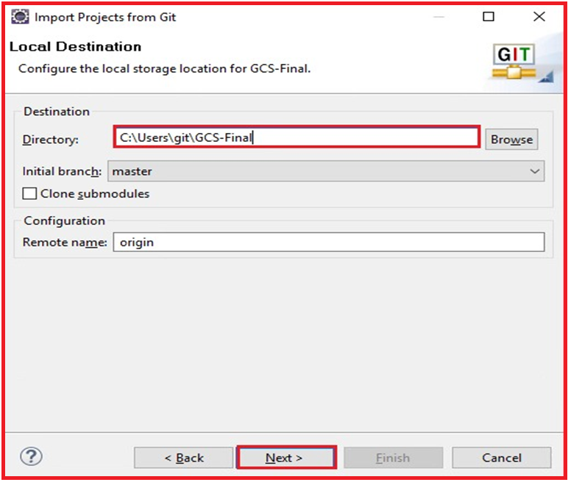

20. Enter the valid Username & pass the token copied in 9th step into the Password text field.

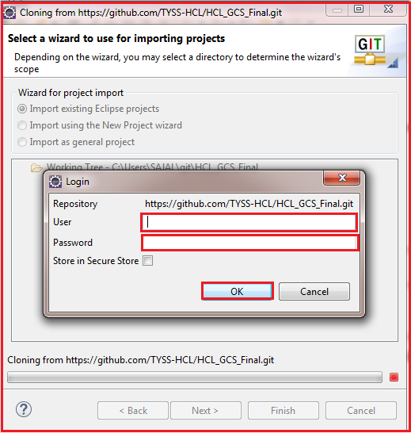

21. Click on next.

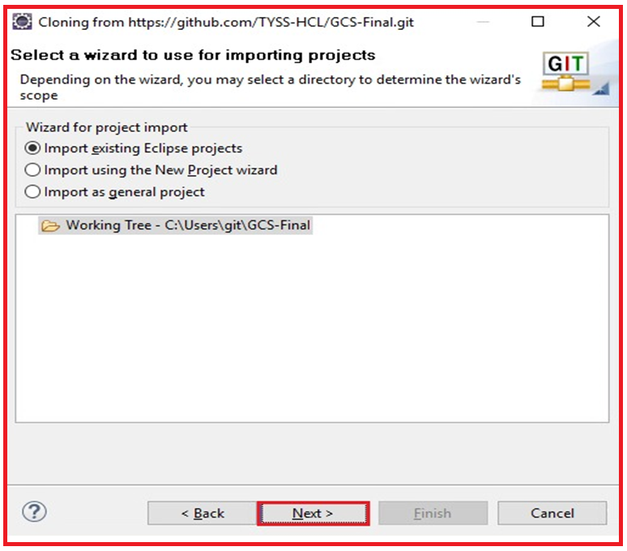

22. Click on Finish.

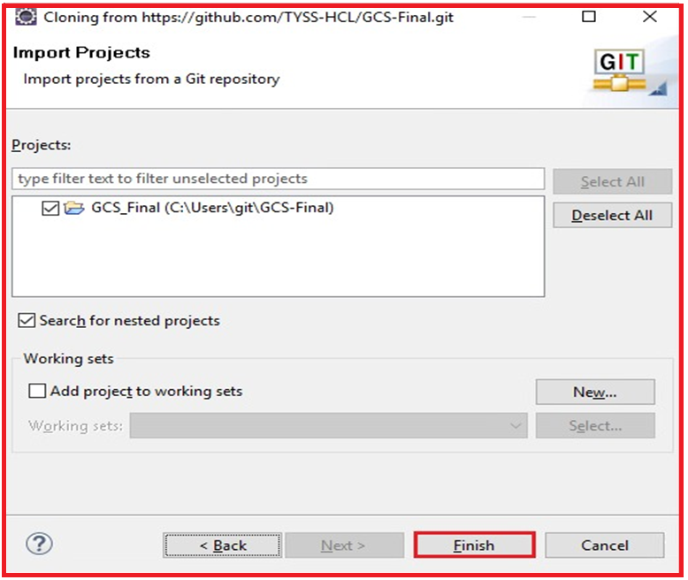

**Method 2: Import the code in Eclipse from downloaded ZIP file:**

1. Open the given URL <https://github.com/> and Click on sign in.



2. Enter your credentials and click on sign in.



3. Project has been shared to the mentioned Git account by the Lead/Manager. Accept the invitation in email and you can see the project in your git account. Click on project.

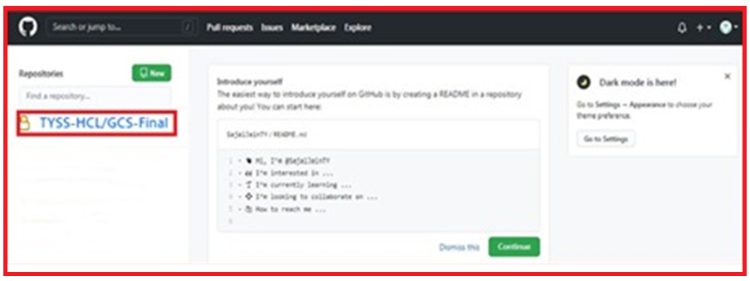

4. Click on code then click on Download Zip. Zip file get downloaded in your system.

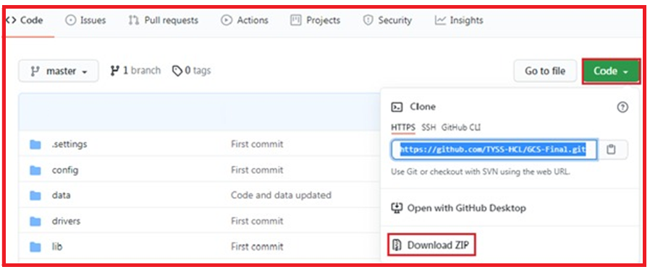

5. Unzip the file.

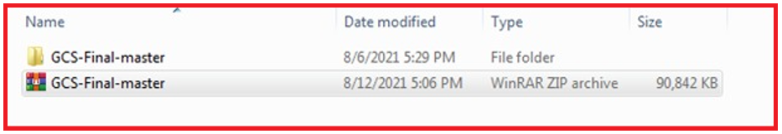

6. Open the eclipse and create a workspace (Create a folder in your system) and click on launch.



7. Click on file then click on import.



8. In General option click on Projects from Folder or Archive then click on next.

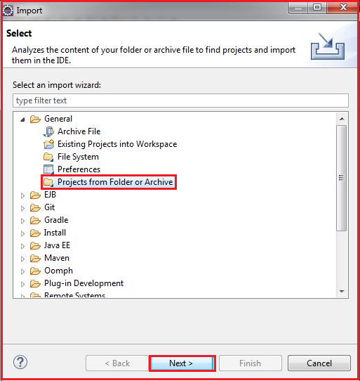

9. Select the downloaded unzipped folder through directory then click on finish.

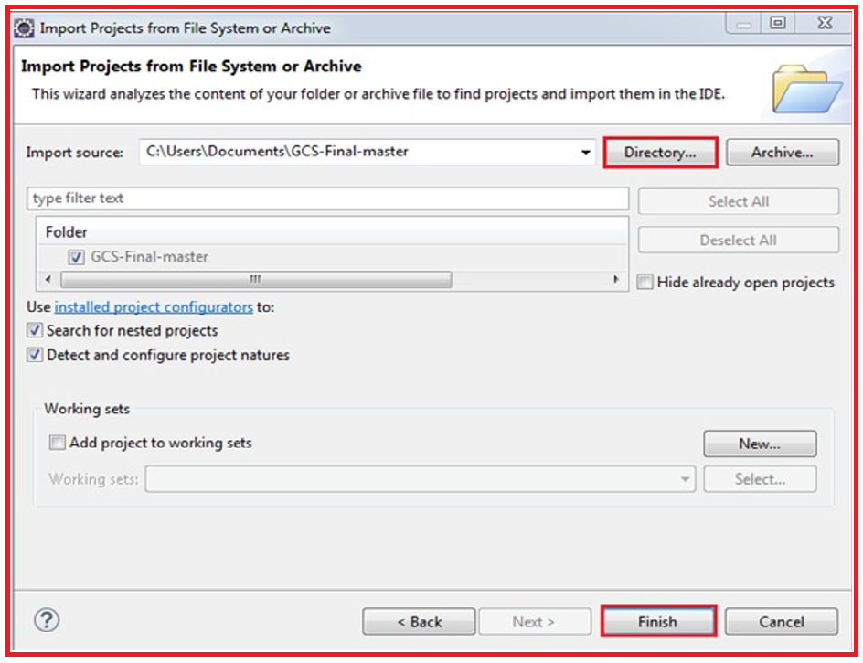

**How to Execute the Test Scripts**

**Method 1: Using Eclipse IDE:**

1. Open the Project in the Eclipse IDE and open the Controller.xlsx file

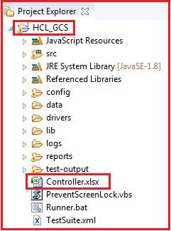

2. Enter the execution status as ‘YES’ for the Claim type that need to be executed in the Flow controller sheet.

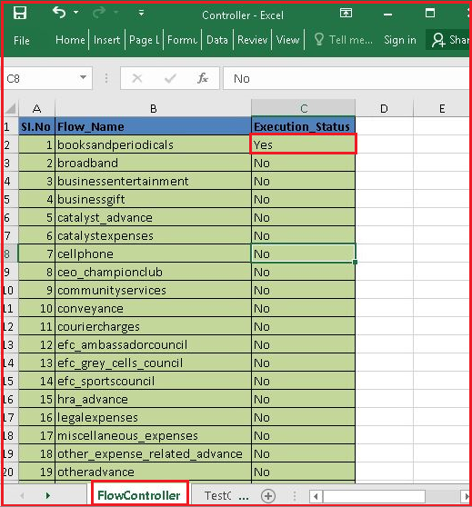

3. Go to the Test controller sheet and change the execution status of scripts for the selected claim type.

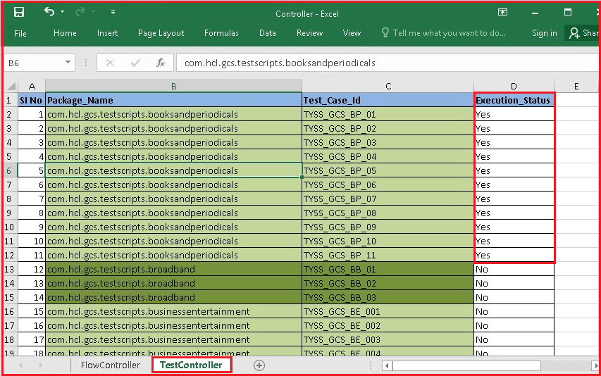

4. Go to the Configuration sheet and Mention the browser for execution.

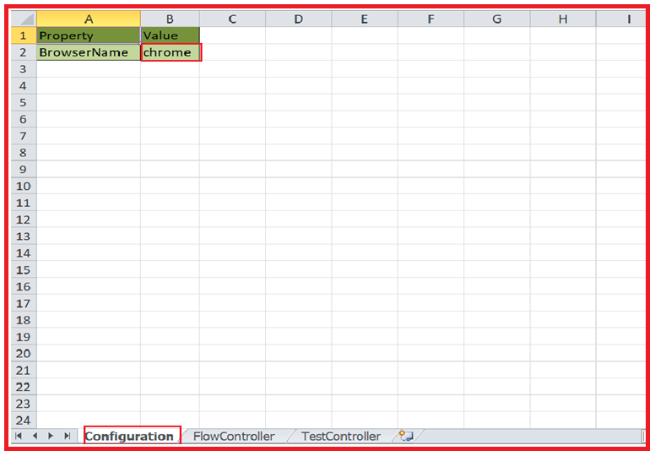

**Note:** if you want to execute the scripts in Edge browser then need to uncomment the following code in CreateDriver class present in com.hcl.gcs.baseutil package because edge driver is supported in Selenium 4.0(beta version).

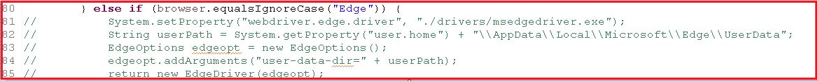

5.Save the controller file.

6.Right click on the TestNG Runner class and select run as java application.

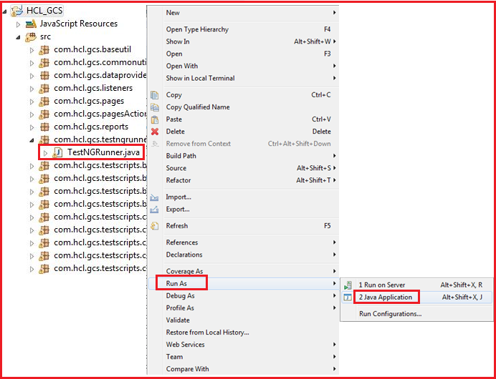

7.Refresh the project.

8.Double click on PreventScreenLock.vbs file.

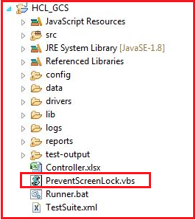

9. Right click on TestSuite.xml, select run as TestNG suite.

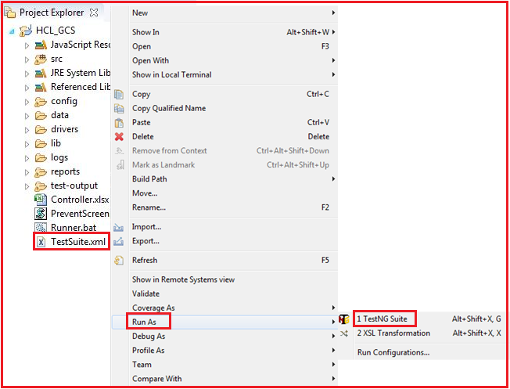

**Method 2: Using Runner.bat file**

1. Open the Project in the Eclipse IDE and open the Controller.xlsx file



2. Enter the execution status as ‘YES’ for the Claim type that needs to be executed in the Flow controller sheet.



3. Go to the Test controller sheet and change the execution status of scripts for the selected claim type.



4. Go to the Configuration sheet and Mention the browser for execution.



**Note:** if you want to execute the scripts in Edge browser then need to uncomment the following code in CreateDriver class present in com.hcl.gcs.baseutil package because edge driver is supported in Selenium 4.0(beta version).



5. Save the controller file.

6. Double click on PreventScreenlock.vbs file.



7. Double click on Runner.bat File in the source folder.

Runner.bat file internally execute the TestNGRunner.java class which creates TestSuite.xml file and then execute this xml file.

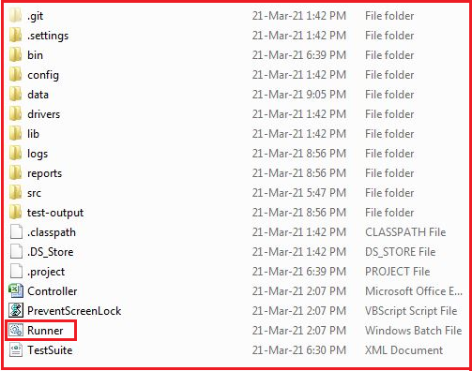

**Result analysis**

**Extent Reports**: After the execution the extent reports are saved in the **reports** folder in the project directory. Refresh the project directory and get the newly generated reports.

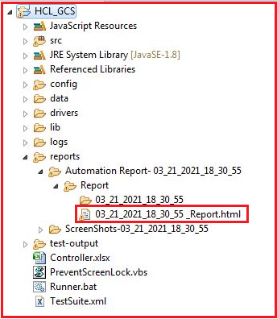

The below picture depicts the html report which is obtained in the report folder after the completion of the execution.

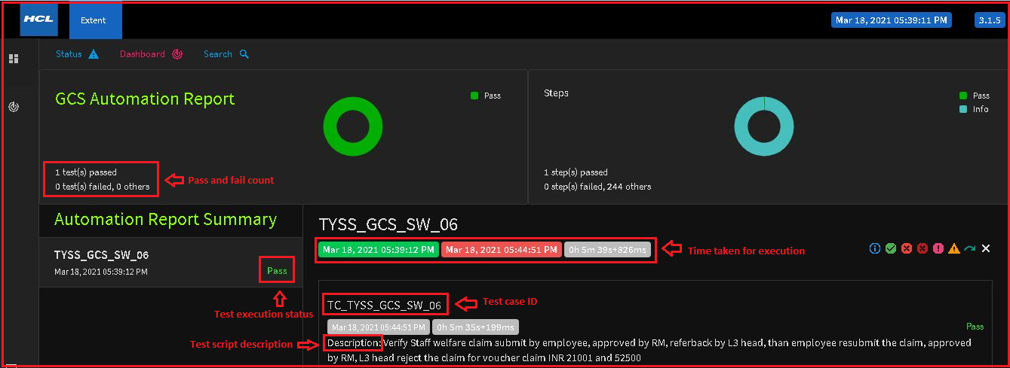

Below picture shows the different status obtained in the report after the completion of the execution.

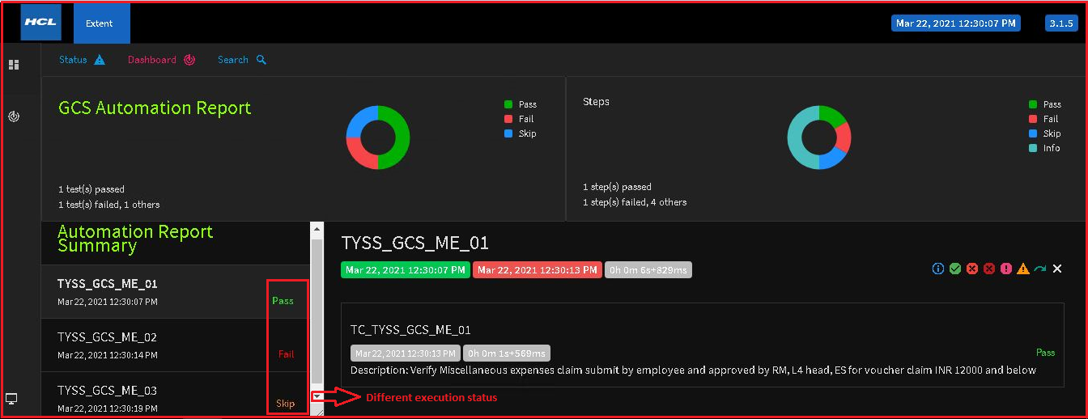

The below picture depicts the detailed execution steps. The major application validations are highlighted in blue; business validations are highlighted in green.

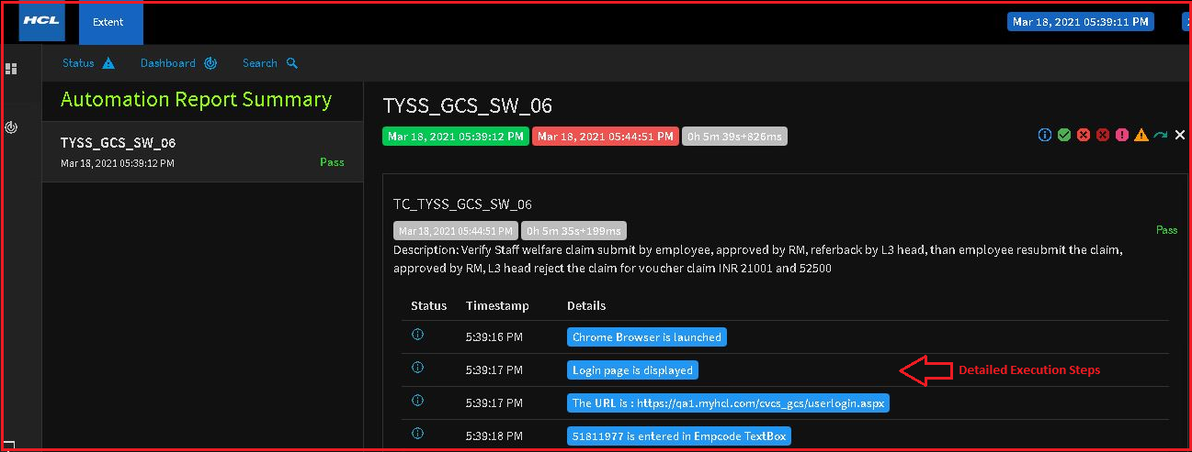

The following picture shows that user can apply the various filter and sort the detailed steps.

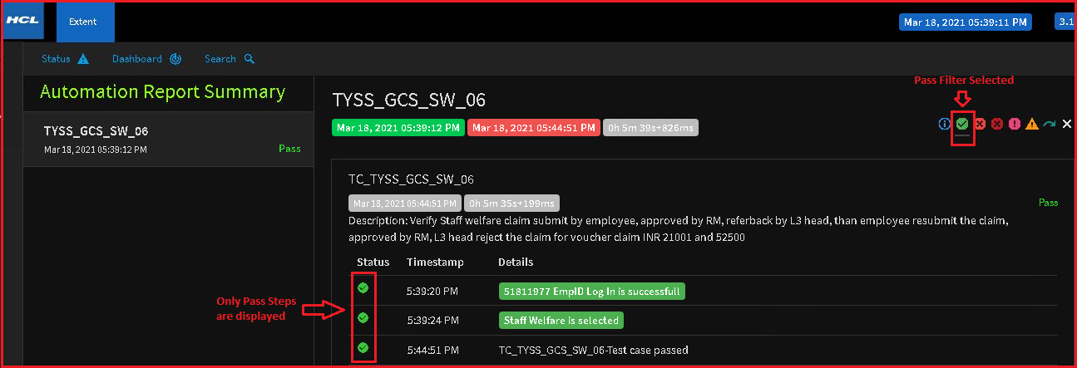

**Log4jReports**: After the execution the log4j reports are saved in the **logs** folder in the project directory.

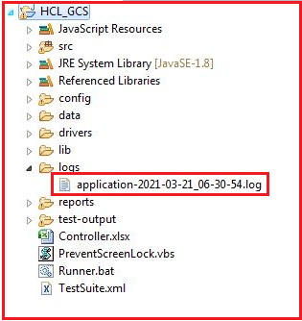

The logs of the execution are updated in the logs file with the Timestamp as shown in below picture.

